Power Consumption Measurements of East West Universities Data Center

Rashedul Amin Tuhin
Department of Computer Science and Engineering
East West University Dhaka, Bangladesh
mcctuhin@ewubd.edu

Afia Nishat Kanta
Department of Computer Science and Engineering
East West University Dhaka, Bangladesh
2019-3-60-97 @std.ewubd.edu.

Anik Saha
Department of Computer Science and Engineering
East West University Dhaka, Bangladesh
2019-1-60-220 @std.ewubd.edu

Md. Ashraful Hasan
Department of Computer Science and Engineering
East West University Dhaka, Bangladesh
2019-1-60-219 @std.ewubd.

Monjurul Alam
Department of Computer Science and Engineering
East West University Dhaka, Bangladesh
2018-03-30-035 @std.ewubd.edu

Abstract— Large-scale Internet-based services are operated by energy-intensive, vital data centers. Every big institution maintains a data center to save and operate data. East West University, a renewed private university in the capital city of Bangladesh Dhaka also has a data center. The energy consumption of the data center remains an open question. As there is no integrated sub-meter for the data center the university authority didn’t know how much power is consumed by it and how much it costs. By collecting the data from data centers’ Main Distribution Boards, energy consumption was measured and an average cost for the data center was shown. Also, the drivers and barriers to establishing a sub-meter for the data center were found. Based on these findings, we wrap up the study by outlining the major issues that need to be addressed in future research to create accurate and effective data center power models.
Keywords— Energy efficiency, cloud computing, energy consumption, data center, energy consumption modeling.

Introduction
Data centers are massive, 24/7, mission-critical computing infrastructures that are driving the explosive growth of the IT sector and reshaping the whole economy. Two phenomena, in particular, have increased the criticality of data centers. First, due to the need for computing, processing, and data storage from a variety of large-scale cloud services, such as Google and Facebook, there are several huge data centers with thousands of servers. Telecommunications companies like British Telecom, banks, and others (sometimes with millions of servers).
Second, the need to support a wide range of applications—from those that operate for a brief period of time to those that run continuously on platforms with shared hardware—has encouraged the development of large-scale computing infrastructures. Consequently, data centers have been hailed as one of the main enabling technologies for the quickly expanding IT industry, with a market value of 152 billion US dollars worldwide by 2016. High-scale computer infrastructures like data centers have large energy budgets, which has led to a number of problems with energy efficiency.

First, for a variety of reasons, data centers have a significant economic impact. The energy used by a typical data center could power 25,000 homes. Up to 100–200 times, more electricity may be used in data center spaces than in typical office spaces [5].
Additionally, every five years, the cost of powering a typical data center doubles [1]. Power expenses have therefore become a substantial burden for today's data centers due to the sharp increase in electricity demand and growing electricity costs. Power expenses can occasionally be higher than hardware prices. Second, energy use in data centers causes a variety of environmental issues. For instance, in 2005, the total power consumed by data centers accounted for 1% of all electricity used in the US and produced as many emissions as a country of similar size to Argentina. According to estimates from 2010, data centers consumed 1.1% to 1.5% of the total power consumed globally, compared to 1.7% to 2.2% in the US [2]. Data centers utilized 270 TWh of energy globally in 2012, with a Compound Annual Growth Rate (CAGR) of 4.4% from 2007 to 2012, according to recent research by Van Heddeghem et al. Due to these factors, data center energy efficiency has supplanted the conventional concerns of availability and security as the top issue for operators of data centers. Finally, servers still use a lot of energy even when they are idle. These servers can be turned off to provide significant savings. To cut back on data center electricity use, this and additional steps like workload consolidation must be taken. These energy-saving methods also lower system performance, illustrating the difficult trade-off between energy efficiency and good performance.
The energy utilized by infrastructure facilities (such as cooling and power conditioning systems) and IT equipment (such as servers, networks, storage, etc.) may be roughly separated into two groups.
East West University has a data center monitored by Information and Communication Services. The data centers play a crucial role in the university's essential operations, which include providing secure data storage for research, academic, and campus servers and applications.
But it consumes a huge amount of energy, and as a result, the University needs to pay a significant amount of wealth for it. Numerous initiatives have been made to increase IDC's energy efficiency, including network power management, energy-efficient Chip Multiprocessing (CMP), IDC power capping, and storage power management solutions. The establishment of a Data Center service model is thus examined in this article for its greater effect and sustainability in East West University as a timely necessity. In this paper, the options for reducing the budget for the Data Center are analyzed.

Background
For extensive Internet services, data centers strive to provide a dependable and scalable computing infrastructure. [1]. The primary function of a data center is to store and deliver data, but this requires a significant quantity of electricity. The majority of the time, data centers operate significantly below their capacity despite being routinely planned for peak activity. A previous study on power measurement has provided data on power usage for several data center switches for various traffic patterns. A network-wide energy optimizer called Elastic-Tree constantly tracks the traffic in data centers. [3] The country's expanding digital and e-commerce services play a major role in determining and qualitatively analyzing the limitations, promises, and scopes of building Data Centers. A power consumption study is given to identify the needs and current data center facilities. The East-West University's data center requires optimization and lower power consumption in light of the contemporary service-oriented and hyper scale data centers created by the top e-commerce giants like Google, Amazon, Netflix, and Shutterfly.///////////irst, confirm that you have the correct template for your paper size. This template has been tailored for output on the A4 paper size. If you are using US letter-sized paper, please close this file and download the Microsoft Word, Letter file.

Maintaining the Integrity of the Specifications
The template is used to format your paper and style the text. All margins, column widths, line spaces, and text fonts are prescribed; please do not alter them. You may note peculiarities. For example, the head margin in this template measures proportionately more than is customary. This measurement and others are deliberate, using specifications that anticipate your paper as one part of the entire proceedings, and not as an independent document. Please do not revise any of the current designations.

Problem Statement
Due to its significant economic, environmental, and performance effects, data center energy efficiency has achieved a vital role in recent years. First, for a variety of reasons, data centers have a significant economic impact. The energy used by a typical data center could power 25,000 homes. Up to 100–200 times, more electricity may be used in data center spaces than in typical office spaces. your text and graphic files separate until after the text has been formatted and styled. Do not use hard tabs, and limit use of hard returns to only one return at the end of a paragraph. Do not add any kind of pagination anywhere in the paper. Do not number text heads-the template will do that for you.

Aim
To explore the energy consumption-related issues of data centers.

Objectives
The objectives of the study are given below:
- To assess the energy consumption of IT equipment at the EWU data center
- To identify the drivers and barriers of sub-metering of IT equipment at the EWU data center.

Related Works
In this essay, the functions of data centers are conceptualized data centers. The current status of Bangladesh's data center services is insufficient to meet the long-term expectations of the country's digital transformation, which calls for the correct fusion of cutting-edge technology with efficient operational plans and digital services. As a result, the project examines the needs and prospects for the strategic development of Data Centers for the nation's expanding digital and eCommerce services. [1]. An updated data center service model is given taking into account the contemporary service-oriented and hyper-scale data centers. The suggested service model aids us in identifying a set of strategic considerations for the growth of Data Centers in conjunction with the current facilities and our market study. [2]. The study begins by evaluating several methods for locating minimum-power network subsets for a variety of traffic patterns. The project carries out and evaluates Three network companies' production OpenFlow switches were used to build Elastic-Tree on a prototype testbed. [3]. Using actual traces from a live e-commerce website, they also analyze the trade-offs between energy efficiency, performance, and resilience. Our findings show that Elastic-Tree can conserve up to 50% of network energy for workloads in data centers while still being able to handle traffic spikes. [4]. They conclude by demonstrating how a network administrator may set up Elastic-Tree to meet their performance and fault tolerance requirements while reducing their network power expenditure.

A data center maintains a sizable volume of data for storage, processing, and dissemination while centrally locating the computer and networking resources. Modern data center configurations are frequently "hyperscale," allowing for quick scaling or growth without requiring significant adjustments to the hardware and network architecture. However, Bangladesh's current Data Centers and the services they provide are still insufficient.[5] Additionally, such Data Centers were constructed expressly to serve certain corporations. This article consequently examines the construction of a Data Center service model for its increased effect and sustainability in Bangladesh as a timely demand. The condition of the Data Centers in Bangladesh, their future services, and present important market analysis data have been evaluated using current Data Center facilities. [6]. On the other side, according to Uptime Institute data, Bangladesh only has four accredited Data Centers. Emerging Data Center services include a wide spectrum, from straightforward web hosting to contemporary cloud-based software-as-a-service, and are provided to consumers "individually" or "combinedly”.

Research Question
- What is the most effective way to measure the energy consumption of IT equipment?
- What are the advantages of sub-metering?
- What are the economic effects of sub-metering at the EWU data center?

METHODOLOGY
Primary data is used in this study. Data is collected through a survey. Quantitative data is used to assess the energy consumption of IT equipment at the EWU data center. To identify the drivers and barriers to the sub-metering of IT equipment at EWU, qualitative data was used. [8]

Data Collection from the data center
Data was taken from EWU data centers MDB box as the project works for EWU university data center only. Interviews were taken with in charge of the EWU data center Md Mahfuz Alam, Assistant Systems Manager. As he is in charge of the EWU data center he was chosen for gaining better answers.

Interview for sub metering
The other interview was taken from Md. Rafiqul Islam, Assistant Engineer (Electrical). He was chosen as he was the most convenient one and Md Mahfuz Alam referred to him. The current study concentrated on real-time organizational information collected from the live measured readings from power meters from East West Universities Data Center. In this section how much energy has been consumed by the East West University Data center is being measured.

Data were collected systematically from the East-West University Data Center. This project's first step was the data center’s energy consumption measurement. So, data was collected at different times and on different dates. Quantitative data was collected here from the MDB of the data center.
This project's second step was collecting data for the sub-metering system. Qualitative data was found through an interview. [8]

There is some limited manpower who knows about Data Centers and IT equipment so an interview is much more efficient than a survey. Collecting data from MDB is more easier and correct than taking measurements manually.

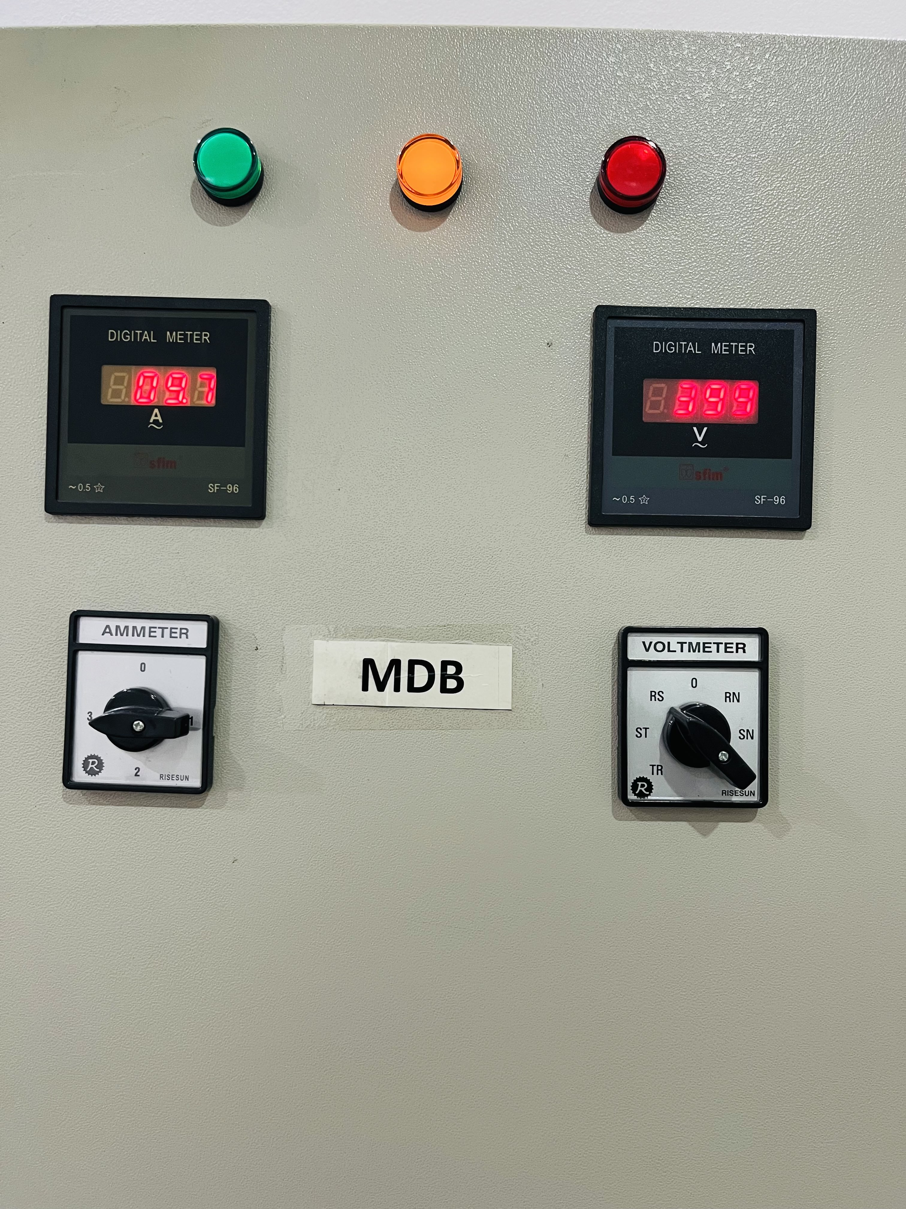

Fig 1: MDB(Main Distribution Board)

Research Ethics
Our project works were at our own university's data center. So it is quite easy for us to work on this project. Ampere and voltage between some fixed time intervals were collected from MDB from the data center power room with the help of MD Mahfuz Alam (Assistant system manager) and calculated the power and cost of the EWU data center. This kind of data collection isn't that serious or sensitive. Regarding the driver and barrier to installing a sub-meter for the data center, objective data was collected through an interview with Md. Rafiqul Islam, Assistant Engineer (Electrical) EMD, East West University. This interview doesn't have any risk and data is stored securely.

Experimental RESULT
Data was collected from the MDB meter as permission was taken from the EWU ISC department attached in the appendix. As MDB shows ampere and voltage there is no risk of danger when collecting data. For data preparation, Microsoft Excel is used. Data could be easily measured if there was a sub-meter for the Datacenter. There are 3 phases for power supply at the data center. [8]
MDB(Main Distribution Boards) at the data center show Voltage and Ampere reading continuously for each phase. For different time and date reading from MDB was taken and the total bill was calculated at 10.56 taka per unit cost. As East West University gives 10.56 taka per unit at peak hhours As the data is quantitative, a couple of tables are used to show them.
The project also worked to find drivers and barriers to sub-metering of IT equipment at EWU. It's found that there are two kinds of barriers to installing a sub-meter. First is the administrative barrier as there is no initiative taken for establishing a sub-meter for the data center. Another one is technical barriers, as data centers will need to shut down for 30+ minutes and which will hamper the service of the data center.
There are some drivers too. As Md. Rafiqul Islam, Assistant Engineer (Electrical) said that” If the ICS department gives us any requirement we will install a sub-meter for the data center with the help of accounts. ” He also added,” As East West University pays the current bill from the main meter, a sub-meter at the data center will not help to pay the bills”. So it can be said that as there is no need for a sub-meter at the data center for the ICS department, it's not implemented yet.
Appendix table 1 to 6 is shown. From those tables:
The total bill of the first interval (33.6624+34.1433+29.3344) = 97.1401
The total bill of the second interval (27.8291+27.4983+27.8968) =83.2242
The total bill of the third interval (36.825+36.9159+36.4332) = 110.1741
The total bill of the fourth interval (59.5795+60.4307+51.9193) = 171.9295
The total bill of the fifth interval (37.3661+37.4579+32.3044)=107.1284
The total bill of the sixth interval (30.1514+31.5747+26.1043)= 87.8304
Total bill for 403 minutes = 657.4267 taka
Here, the total time was 5 hr and 1 hr 43 min in total 403 minutes. 657.4267 taka is the Data Centers’ bill for 403 minutes. Per minute it will need 1.63 taka. Per hour data center costs 97.87 taka. In a day 2347.2 taka. In week 16430.4 taka, 70416 taka monthly and 856728 taka yearly.

Discussion

Accurate assessments of the energy consumption of IT equipment are required in order to manage it properly. While there are several technologies that purport to quantify or estimate consumption, each approach has pros and problems of its own. The first and most apparent technique is to keep an eye on the equipment's real usage while it's in operation. This approach is the simplest to utilize because it doesn't rely on any additional infrastructure. Its numerous drawbacks, however, could make it less suitable in a production situation. First of all, because so much of the total energy used is lost as heat and because the monitoring equipment typically needs access to a representative sample of the circuit feeding the equipment in order to calculate its energy consumption, it is challenging to measure the amount of energy consumed by a single piece of equipment with any degree of accuracy.

The management of IT systems must take into account energy usage. There are several techniques to gauge energy usage; which is the most efficient? The cost of energy is increasing on a worldwide scale and is predicted to do so in the upcoming years. Numerous enterprises are being significantly impacted by this rising expense. Depending on the technology utilized and the choice of deployment method, energy-efficient solutions can save an organization's expenditures by as much as 30% or even more. By lowering emissions and carbon footprints, they also aid businesses in achieving environmental objectives. Effective energy management, in the opinion of more than 50% of firms, is crucial to their success.[2]

Sub-metering makes it possible to monitor how much power is used daily or monthly, giving a precise accounting of costs at the EWU data center. so that it may decide how to cut costs in an educated manner. For instance, you may decide to turn off any inactive appliances, install energy-efficient lighting throughout, or swap out outdated equipment for newer, more energy-efficient ones. enabling the EWU administration to understand the precise functions of the data center's equipment.

Monitoring and controlling IT equipment becomes more crucial as the EWU data center expands. Sub-metering is the technique of keeping track of and measuring a particular feature of an asset, such the amount of electricity or water used. In an institute, there are frequently several data centers spread out over several buildings. It would be challenging to calculate the total water and electricity use for each building in this situation. Keeping track of how much power is being used in each building on campus may prove to be a costly exercise for the IT department, but at EWU it is relatively simple because the data center is located in one location. In the EWU data center, setting up a sub-meter is not difficult, but neither a request for application nor any administrative instructions have been sent to the admin. The authorities is always ready to put it up on their own if that becomes required. There is a barrier that prevents the top EWU authority from updating it, and neither the department of electric nor the data center authority are in need of it.

Both the EWU data center and the university have benefited financially from sub-metering in a number of ways. An improvement in energy efficiency and a decrease in total expenses are the two main advantages of submetering. Individual servers can be turned off during times of low demand, resulting in a large decrease in energy expenses, because the power consumption of each one is no longer monitored. Additionally, because the control panel keeps track of each server's specific consumption, invoicing is streamlined, making cost management much simpler. Over the last four years, savings of millions of dollars have been realized thanks to decreased operational expenses caused by these advantages. These savings have been put to use for the institution as a whole to pay for additional facilities upgrades or to cover the cost of the new data center's construction. As a result, EWU has avoided raising tuition or adding to its debt load in order to sustain its IT budget. In addition to these monetary advantages, the environment has benefited from the decrease in energy expenditures.

Conclusions AND FUTUREWORK
Sustainable and impactful development of the Data Center is a timely requirement for East West University. The University should implement Tier-IV Data Center to full fill its future goals. The data center is already 10 years old and authorities should think to update it from now as it takes a long time to implement policy by East West University authority. Approximate Data Centers’ energy consumption is found and it will help the authority to implement further policy making. Sub-metering is also possible but needs concern from the authority. Data Center is a very important part of the university still there is lack of care from the authority for it. A top-down approach will easily solve the problems still a bottom-up approach can help in the future.

In an interview data center in charge said that “At the time of advising, course add-drop, grade submission and admission the data center gets hotter than ever”. At our project time there was no advising, course add a drop, grade submission or admission going on, so the power consumption could not be measured at that time.
Power consumption measurements of the University Data Center at a critical time
can be future work.

References

- M. Dayarathna, Y. Wen, and R. Fan, “Data center energy consumption modeling: A survey,” IEEE Communications Surveys and Tutorials, vol. 18, no. 1, pp. 732–794, Jan. 2016, doi: 10.1109/COMST.2015.2481183.
- B M. Dayarathna, Y. Wen, and R. Fan, “Data center energy consumption modeling: A survey,” IEEE Communications Surveys and Tutorials, vol. 18, no. 1, pp. 732–794, Jan. 2016, doi: 10.1109/COMST.2015.2481183.
- Michael. Nunez, ACM Digital Library., and Sigarch., Proceedings of the 6th international conference industry session on Autonomic computing and communications industry session. ACM, 2009.
- J. G. Koomey, “GROWTH IN DATA CENTER ELECTRICITY USE 2005 TO 2010,” 2011. [Online]. Available: http://www.koomey.comhttp://www.analyticspress.com/datacenters.html.
- Institute of Electrical and Electronics Engineers. Bangladesh Section, IEEE Region 10, and Institute of Electrical and Electronics Engineers, 2020 IEEE Region 10 Symposium (TENSYMP) : 5-7 June 2020, Dhaka, Bangladesh.
- A. Shehabi, S. Smith, and D. Sartor, “Lawrence Berkeley National Laboratory Recent Work Title United States Data Center Energy Usage Report: Permalink https://escholarship.org/uc/item/84p772fc Publication Date.” [Online]. Available: https://escholarship.org/uc/item/84p772fcR.
- https://engineersbd.net/bangladesh-electricity-bill-per-unit-2022/Y.
- M. Denscombe, “The Good Research Guide: For Small-scale Social Research Projects,” 2010.

